**Business Question and Visualization Report**

|  |  |
| --- | --- |
| Date | 15 March 2025 |
| Team ID | LTVIP2025TMID26725 |
| Project Name | Visualization Tool For Electric Vehicle Charge And Range Analysis |
| Maximum Marks | 5 Marks |

Visualization development refers to the process of creating graphical representations of data to facilitate understanding, analysis, and decision-making. The goal is to transform complex datasets into visual formats that are easy to interpret, enabling users to gain insights and make informed decisions. Visualization development involves selecting appropriate visual elements, designing layouts, and using interactive features to enhance the user experience. This process is commonly associated with data visualization tools and platforms, and it plays a crucial role in business intelligence, analytics, and reporting

**Business Questions and Visualisation**

1. **Where are the charging stations located across different regions in India, and what types are most common?**

* **Visualization:** Geospatial Map & Bar Chart
* **Explanation:** A geospatial map can display the spread of EV charging stations across India. A bar chart can categorize stations based on type (fast, slow, home, public, etc.).

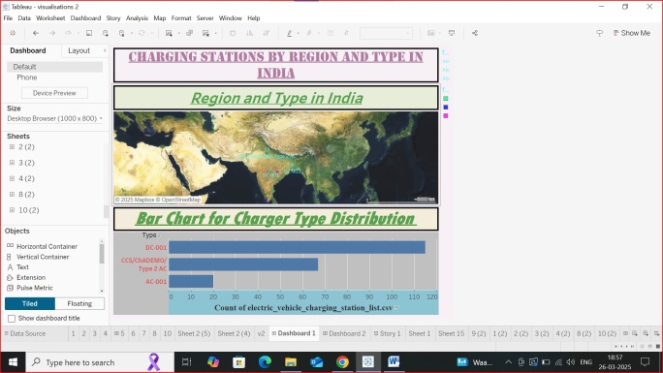

1. **How are EV charging stations distributed across India?**

* **Visualization:** Geospatial Map
* **Explanation:** This visualization helps users find charging stations easily. It highlights densely covered areas and charging deserts.

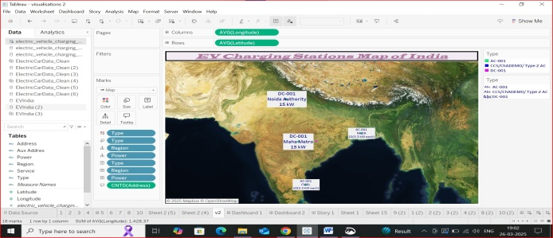

1. **What are the different EV models available in India?**

* **Visualization:** Table or Bar Chart
* **Explanation:** A table can list EV models along with specifications like battery capacity, range, and price. A bar chart can compare models based on key metrics.

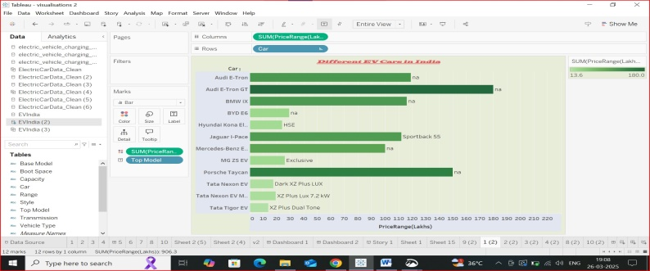

1. **Which EV brands offer the highest top speeds?**

* **Visualization:** Bar Chart
* **Explanation :** The bar chart ranks EV brands by their maximum speed. It helps in identifying high-performance EV options.

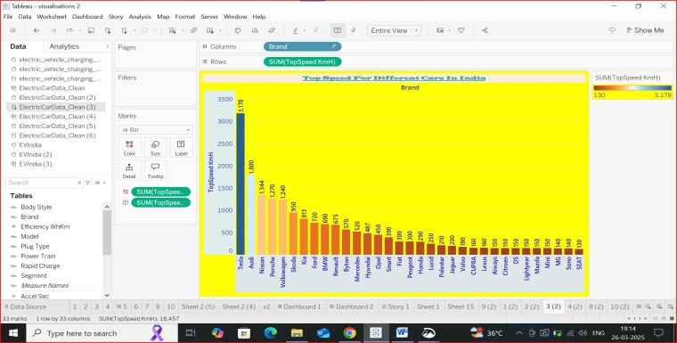

1. **What is the price range of EVs in India?**

* **Visualization:** Stacked Bar Charts
* **Explanation:** A chart shows the distribution of EV prices across different segments. A stacked bar chart can highlight the median price and variations.

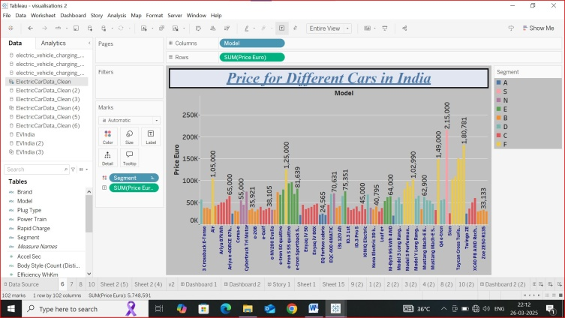

1. **Which EV brands are the most efficient?**

* **Visualization:** Bar Chart
* **Explanation:** Efficiency can be measured by range per kWh. A bar chart ranks the top 10 most efficient EV brands.

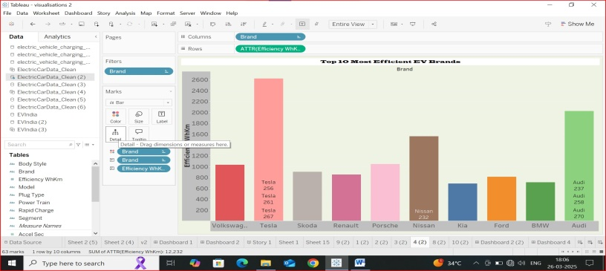

1. **How are EV brands distributed according to body styles?**

* **Visualization:** Tree Map
* **Explanation:** A Tree Map shows the market share of each body style (SUV, sedan, hatchback, etc.). A Tree map can compare the number of models for each body style.

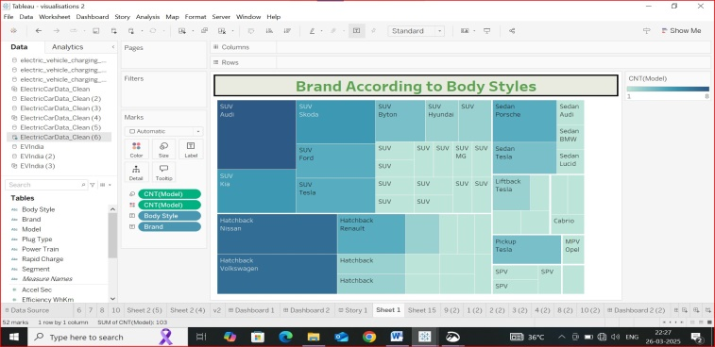

1. **Which brands dominate each powertrain type?**

* **Visualization:** Pie chart
* **Explanation**: A pie chart breaks down brands by powertrain (RWD,AWD and FWD). It helps in understanding the powertrain distribution in the market**.**

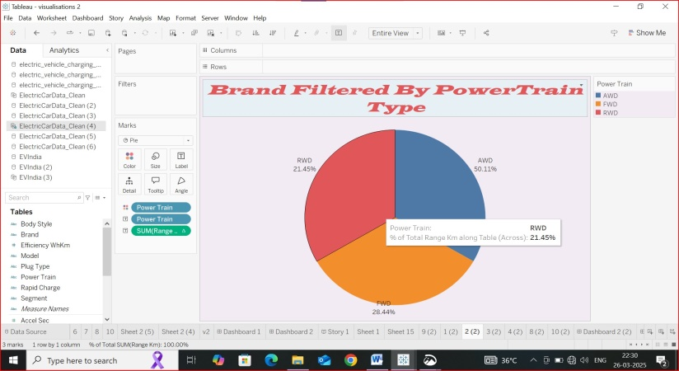

1. **How many models does each brand offer?**

* **Visualization:** Bubble Chart
* **Explanation:** This chart compares the number of models available from different brands. It highlights which brands have a diverse EV line up**.**

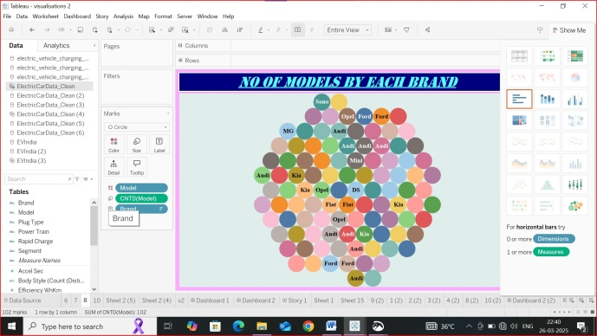

1. **What are the key statistics for different EV brands globally?**

* **Visualization:** Text Table Summary Card
* **Explanation:** The table shows global sales, market share, and top-performing EV brands. It provides a quick overview of the global EV market.

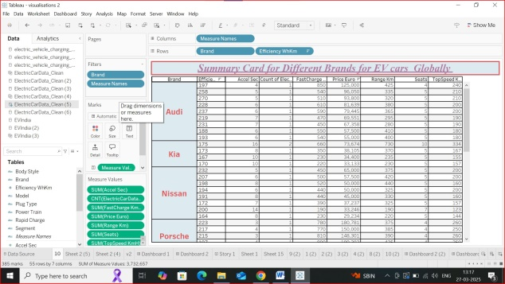

1. **What are the key statistics for EV brands in India?**

* **Visualization:** Text Table Summary Card
* **Explanation:** It summarizes the Indian EV market with brand-wise performance. It includes data on market share, total models, and best-selling EVs.

